**Sudoku Solver using Stacks**

**Abstract**

In this project, we designed and implemented and sudoku solving algorithm and visualizer using Stacks, our modified LinkedLists, as a fundamental data structure. The core purpose of this project was to explore the implementation of a stack-based Sudoku solver using a depth-first search algorithm. Furthermore, we explored the relationship between the number of randomly selected initial constraint values and the likelihood of finding a solution. As well as how the number of initial conditions/constraints correlates to the time taken to solve the board. Taking this further I endeavored to create and implement a considerably faster algorithm, based off of concepts discussed in Donald Knuth’s “Dancing Links” paper, but fell just short of doing so. The files will be included, and the ideas explained as I spent probably a minimum of 30 hours on the algorithm’s implementation. In any case to put the results succinctly as the number of initial filled in cells increased it became considerably slower and more difficult to generate initial boards that were valid. However, these boards, once reached, by and large had no solution, and were incredibly quick to solve/deem solution-less. One exception to this being empty boards and near-empty boards which were trivial to both generate and solve. On the other hand, the easiest and quickest to generate boards were those with less than 10 entries. However, these were generally had the potential to be the most time and labor-intensive to solve, if solvable at all.

**Results**

**Effect of Initial Constraints on Board Generation**

As the quantity of initially filled in cells, or constraints as I will refer to them, increased the time required to generate a board increased substantially. The likelihood that at least one of “n” filled cells on the sudoku board will share a row, column or subgrid with a cell of the same value is given by the function $\frac{1}{9}(\frac{n}{3}-\frac{n^{2}}{27}+\frac{n^{3}}{729})$, as such by the point that n = 27 and $\frac{1}{9}\left(\frac{n}{3}-\frac{n^{2}}{27}+\frac{n^{3}}{729}\right)=1$. It is practically guaranteed that the board will have to be redrawn at least once to generate a valid sudokuz. (To be honest I am horrible at probability, I’ve never taken a class or interest in the subject so I might be wrong here.)

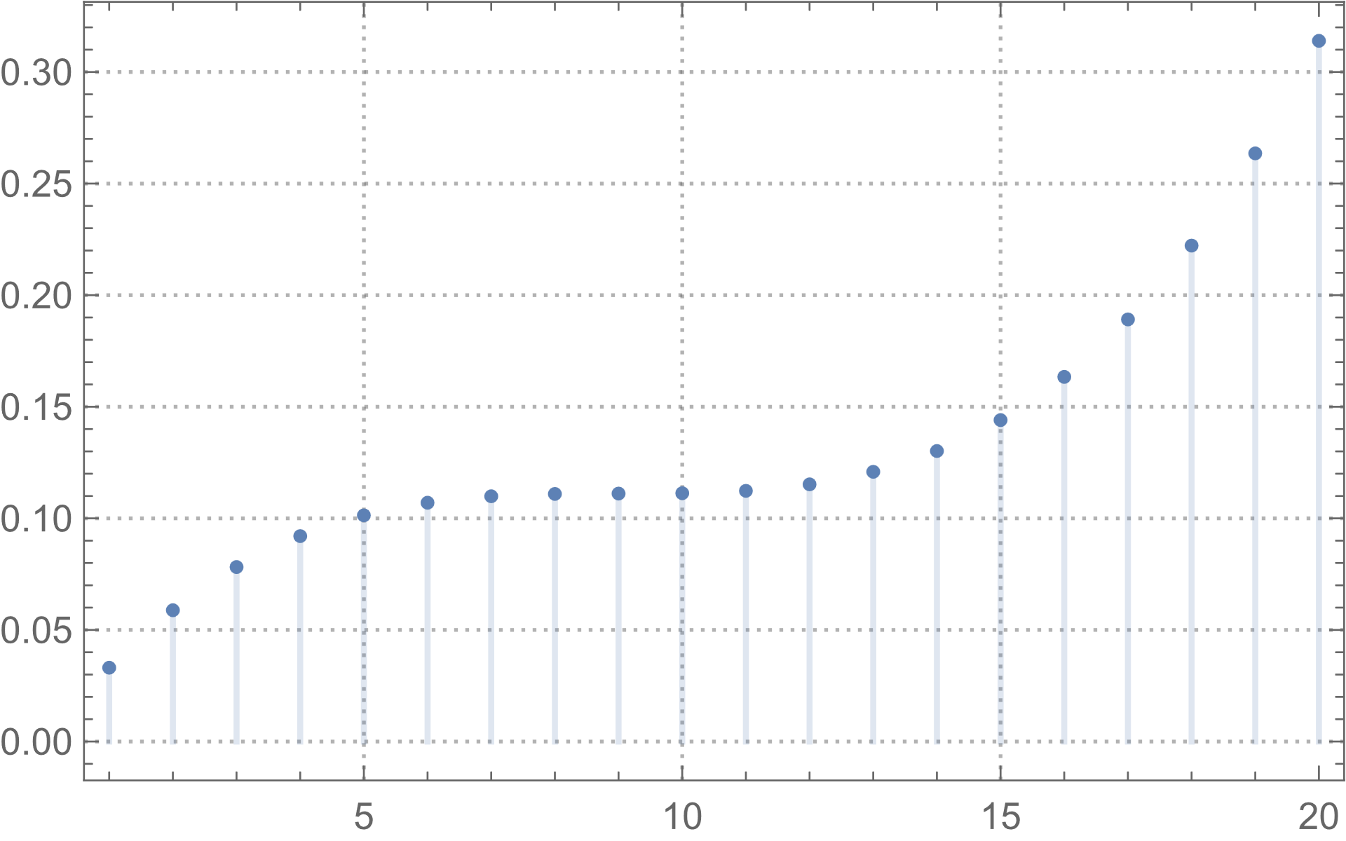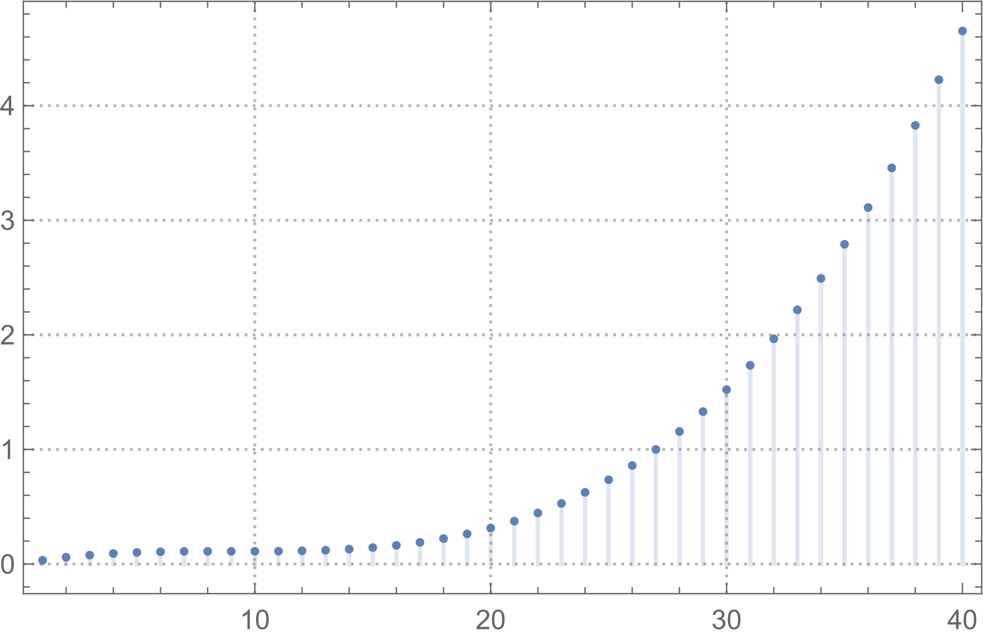

**Effect of Initial Constraints on Board Solving**

Conversely, the trend noted during board generation, as initial counts increased, the time to either solve the board or prove that no solution existed decreased. This is save for particularly small values of initial constraints where the quantity of free variables makes it such that if a solution is not reached early on during the algorithm, the solution space is so vast that the time required to extricate every other possible solution is tremendously long. One such 5-initial constraint sudoku ran continuously for 11 hours without reaching any solution.

On the other hand, Sudoku boards with many initial constraints generally lacked solutions, but were very quickly deemed as such. The time to reach a solution is essentially solely a function of the initial constraints. However, it is not the number of these constraints alone which determine this time. The nature of the constraints themselves determines computation time. Having a lesser number of initial constraints makes it such that there are more possible valid states of the board and many more possible combinations to check. This means that the algorithm is more likely to come across a possible solution, but in the worst case has to check many more possible states. As such, here is where the specific constraints come into play. Depending on the constraints the puzzle may have more or less solutions. The minimal number of filled cells to create a “no solution” board is 15, the minimal number of filled cells to ensure a single solution is 17. It is mathematically impossible to place more than 61 cells such that at least one cell is unconstrained (i.e. not in the same subgrid, row, or column as another cell)The best balance was met around the 15-17 initial constraint mark wherein the quantity of original constraints was not high enough to prevent the board from being solved while maintaining few enough free variables to restrict the size of the solution space.

Here are the five cell solutions:

These first three were quickly generated.

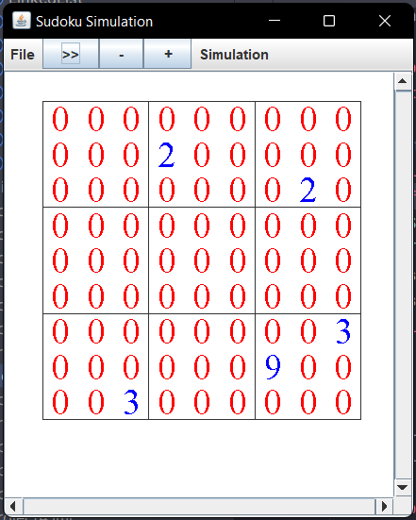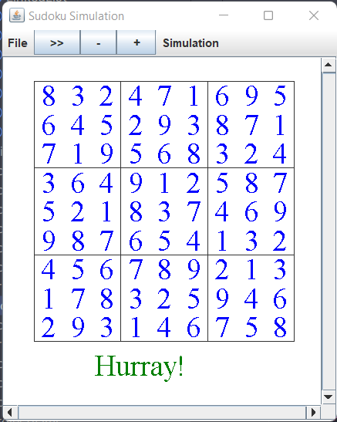

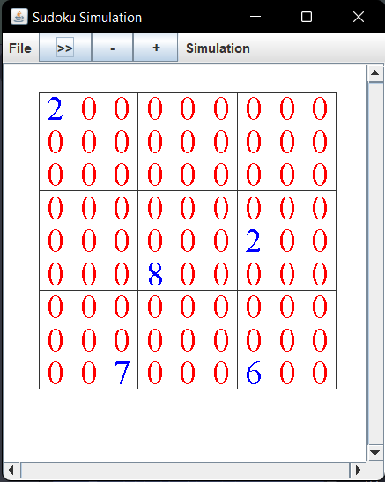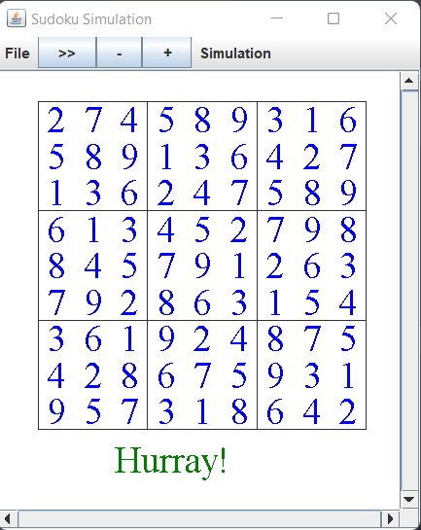

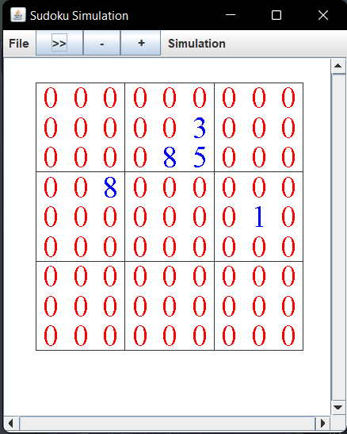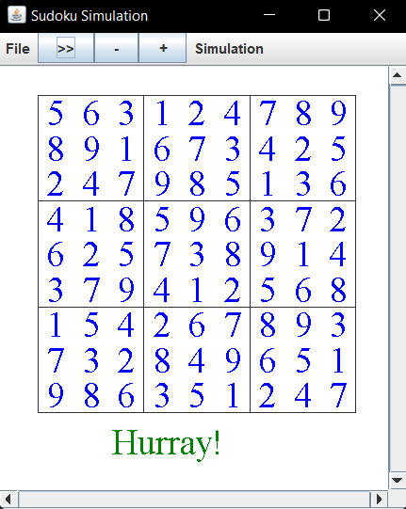

This solution took upwards of 10 minutes to reach:

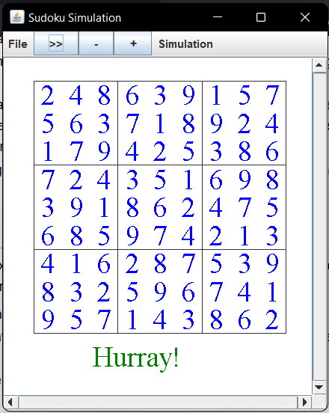

Whereas this solution is yet to be reached even after over eleven hours of continuous processing with over 22 million backtraces.

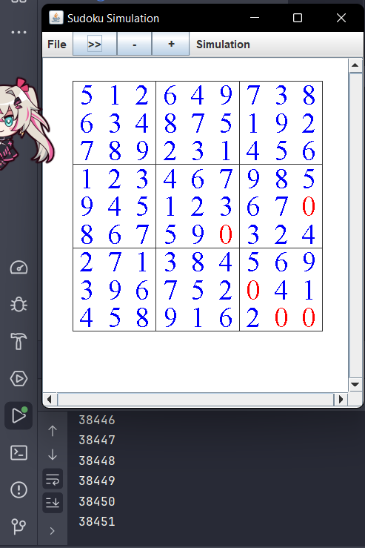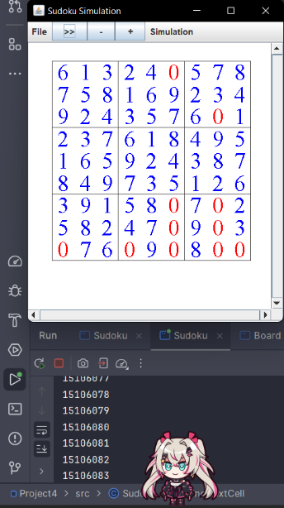 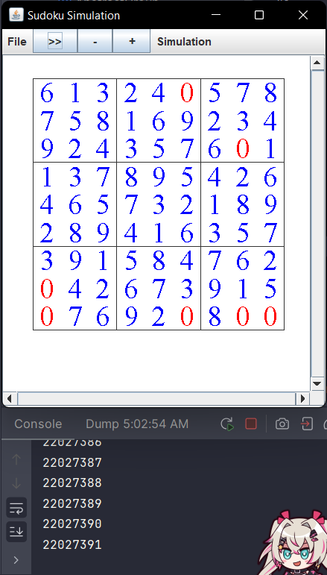

Here are the ten cell solutions:

These first three were quickly generated.

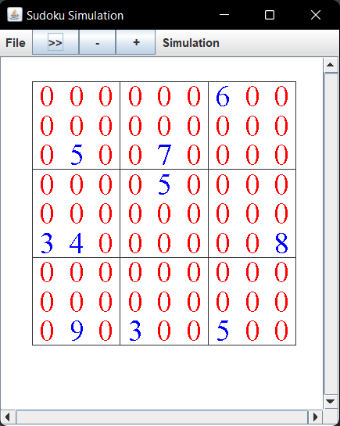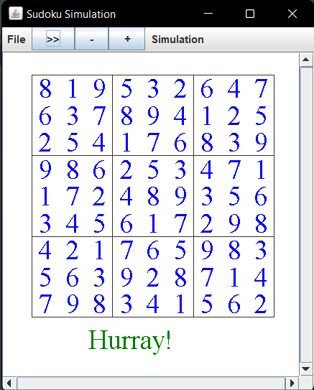

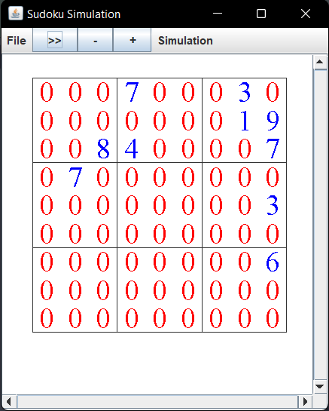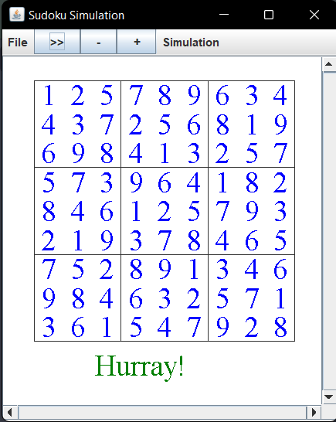

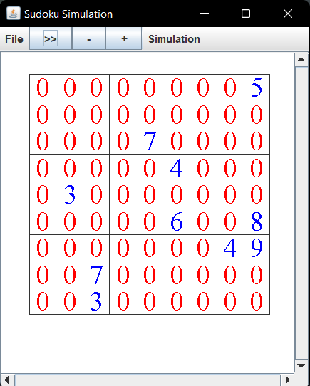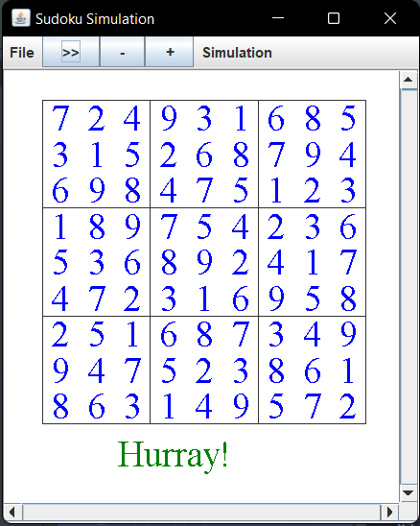

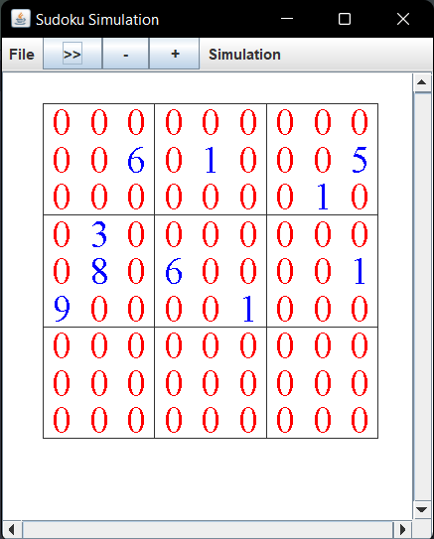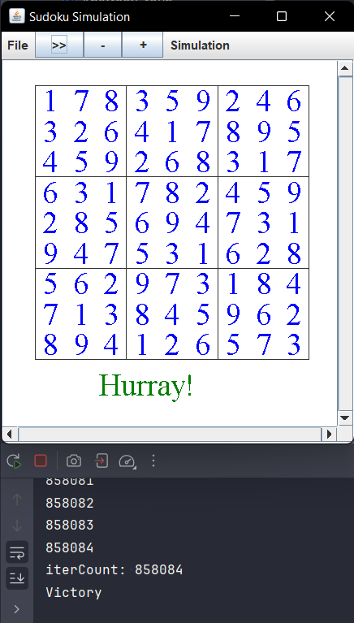The following board was only able to reach a finished state after 858,084 backtraces.

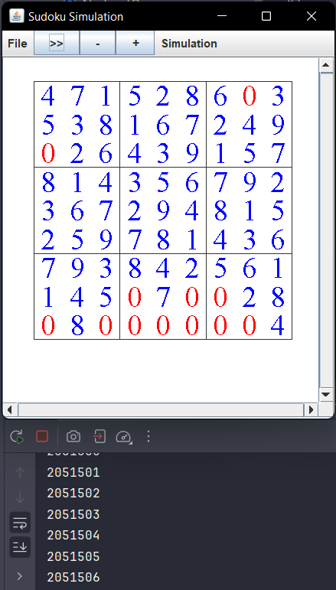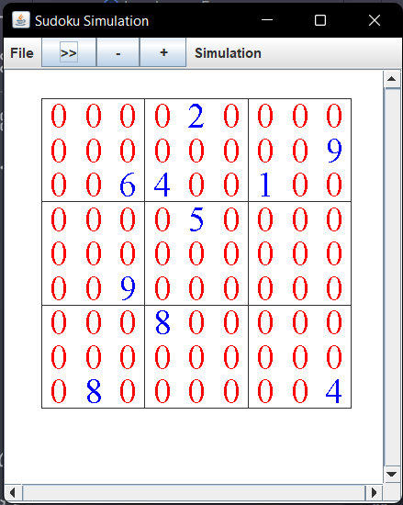Finally, this last board was unable to reach a finished state even after over two million backtraces; however, to free up both threads and memory I halted its execution after backtraces reached this mark. (As an aside, between concurrent runs of this program and the many other windows I had open my memory utilization was at roughly 64 gigabytes. Using Process Monitor I managed to discern that each program run uses a maximum of 136 concurrent threads and about 1700 megabytes of memory. Luckily, CPU usage never exceeded 20% even with other programs running and concurrent simulation.)

Here are the twenty cell solutions:

The first was quickly generated.

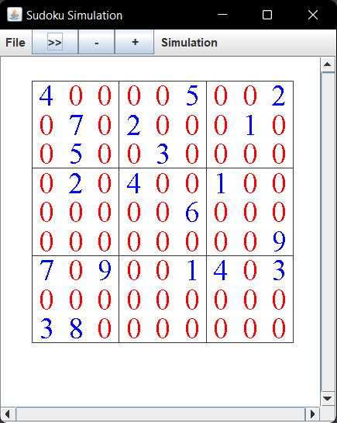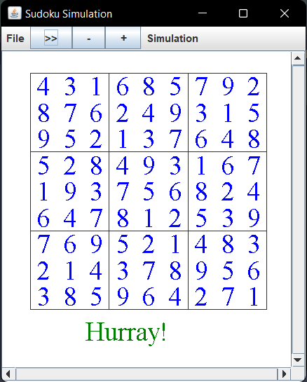

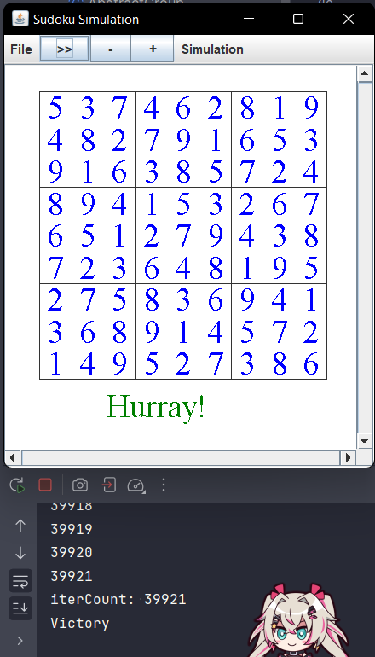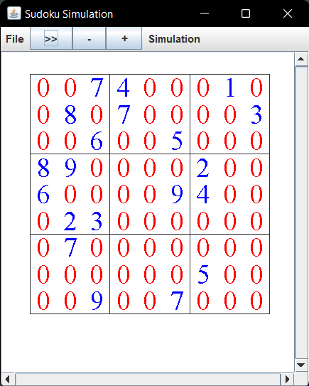The following two were generated moderately quickly, sub 50,000 backtraces.

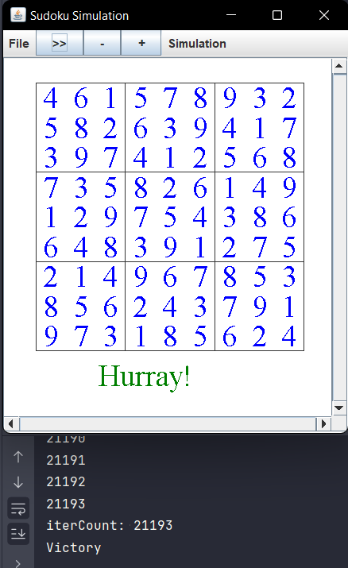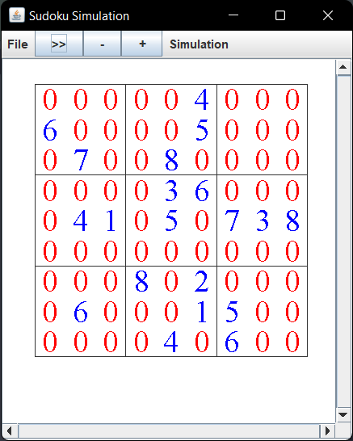

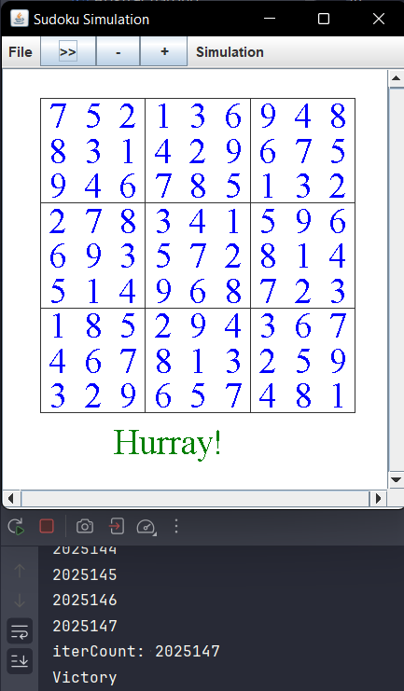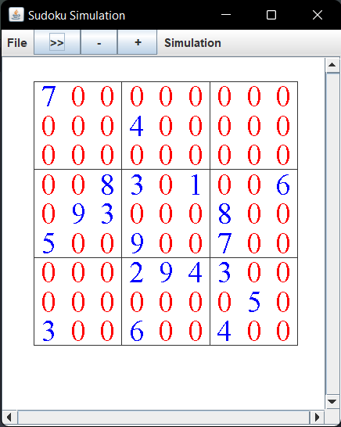This next board generated very slowly, over two million backtraces; however, a solution was finally reached.

The key elements of the AgentSimulation class are:

* Initialization of a 2D landscape named scape with a size of 500x500.
* Creation of 100 SocialAgents and 100 AntiSocialAgents, randomly positioned within the landscape.
* Initialization of a game frame (LandscapeFrame) for visualization.
* Commencement of the simulation.
* Saving images of the simulation frames at regular intervals.
* The simulation continues until all agents have stopped moving.

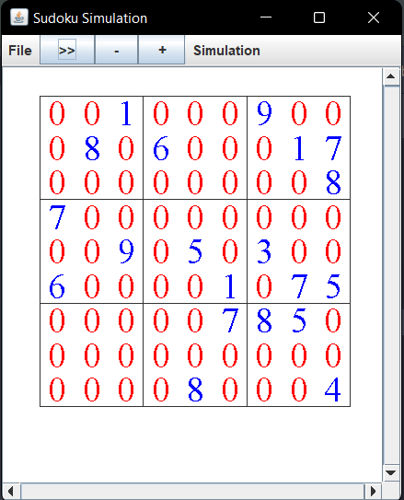The AgentSimulation class advances the simulation by simulating a button press of the advance button defined in our LandscapeFrame.

This is the animation generated with Social and AntiSocial radii of 15 and 11 respectively:



This is the animation generated with Social and AntiSocial radii of 30 and 22 respectively:



As is visible from the figures the simulations using lower radii resulted in more tightly grouped social clusters and less sparsely scattered AntiSocialAgents. This quite closely aligns with expectations as this is to be expected with higher and lower thresholds for neighbor nearness.

An interesting corollary of this is the fact that when radii for social agents were small the simulation took longer, when radii for anti-social agents were small the simulation went quicker.

Similarly, higher density of agents would result in shorter or longer runtimes depending on the social/antisocial agent ratio.

All of these factors are a result of this simulation being effectively an optimization problem for space distribution between two different actor types.

Finally, there is a functional upper limit to the density of agents relative to radius wherein the simulation will never be able to end as the antisocial agents won’t be able to fulfil all their conditions. On the other hand, Social Agents have no upper limit on density and will in fact resolve quicker as density goes up. However, they have a strong lower bound on agent count that will allow for a resolution to the game. All of which are easy to test via the GUI in the AdjustableSimulation class.

**Extensions**

1. **Sector Map for Efficient Computation:**
   * **Implementation**: In this extension, I introduced a sector map to partition the landscape into smaller regions or sectors. Each agent is placed in a specific sector based on its coordinates. This approach allows for more efficient neighbor searching by narrowing down the search space to nearby sectors, reducing the number of agents to consider. It is effectively an implementation of a hashSet. Consider $Z_{n}×Z_{m}$ via the cartesian product. This will represent our sector map for a $n\left(10\right)×m\left(10\right)$ pixel landscape. Now consider, via an ultra-power construction, if we were to insert for each integer pair $\left(x,y\right) ∈{ Z}_{n}×Z_{m}$, a space $Z_{10}×Z_{10}$. Now if we were again, via an ultra-power construction, to insert for each integer pair $\left(x',y'\right) ∈{ Z}_{10}×Z_{10}$, the interval $\left(\begin{aligned}\left[0,1\right)×\left[0,1\right)\end{aligned}\right)∈R^{2}$, we would have a construction equivalent to some segment of the reals. This is the principle under which this method functions. We map each agent to a sector corresponding to their location and use this to limit the number of agents necessary to poll to find neighbors.
   * **Effect**: The implementation of a sector map significantly improves the efficiency of neighbor searches in your agent-based simulation. Without a sector map, searching for neighboring agents would require iterating through the entire list of agents. With the sector map, you can limit the search to agents within the same or adjacent sectors, resulting in faster and more optimized simulations, especially as the number of agents increases. This results in stable simulations with upwards of 20,000 agents in a $500×500$ landscape. The upper limit being a function of agent density makes it such that as long as density stays below some threshold considerably higher numbers are possible.
2. **Graphical User Interface (GUI) with Optional Settings:**
   * **Implementation**: I added a graphical user interface (GUI) to my simulation, providing users with a more interactive and user-friendly experience. This GUI includes various optional settings that allow users to customize the simulation's behavior. Some of the optional settings could include parameters like the number of agents, the size of the landscape, the radius to check for neighbors (individually controllable), the sleep time between updates, and more.
   * **Effect**: The GUI enhances the usability of the simulation. Users can interact with the simulation, modify parameters, and observe how changes affect the agents' behavior and interactions. This feature makes the simulation more accessible and provides a way to experiment with different scenarios without altering the code. It also facilitates experimentation and analysis by enabling users to explore the impact of different settings on the agents' behaviors and patterns.

**Reflection**

In this project, we used linked lists as the primary data structure to manage the agents' positions and interactions. Linked lists were chosen over alternatives like arrays or ArrayLists due to their efficiency in handling dynamic collections of data. Linked lists allow for easy insertions and removals of elements, which are essential for managing agents' positions and movements in a 2D landscape. They also provide more flexibility in memory allocation and do not require a fixed array size, making them suitable for this simulation. The LinkedList structure also allowed us to easily manipulate and organize the agents, something which was essential in the implementation of my hashSet type sector map.

**References/Acknowledgements**

I worked on this project individually; all code is my own. Most JavaDoc is handwritten, some is trimmed down versions of migrated Javadoc (ie in implementing LinkedList I copied in the declarations and Javadoc of things I needed to make/implement and then wrote up the code myself before trimming down and rewriting JavaDoc.) Also, in the linked list implementation I looked at Javas own implementation to make sure I implemented some methods I might need as I wanted to make my code able to function on either implementation. Specifically, I originally wrote it for Javas’s implementation and coded in my implementation afterwards. However, all code is mine and written by me at the end of the day.